MOCKITO

Mockito is a framework use to create mock objects

Mock dependency comes transtivively with the spring-starter-test

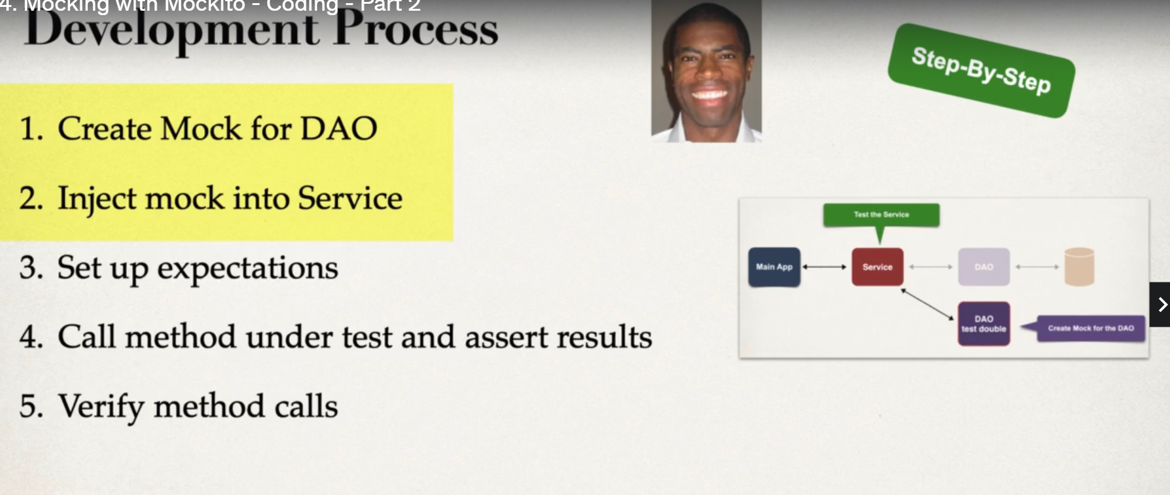

|  |
| --- |
| @SpringBootTest(classes=MvcTestingExampleApplication.**class**)  **public** **class** MockAnnotaionTest {    @Autowired  ApplicationContext context;    @Autowired  CollegeStudent studentOne;  @Autowired  StudentGrades studentGrades;  @Mock  **private** ApplicationDao applicationDao;  @InjectMocks  **private** ApplicationService applicationService;      @BeforeEach  **public** **void** beforeEach() {  studentOne.setFirstname("eric");  studentOne.setLastname("roby");  studentOne.setEmailAddress("ee");  studentOne.setStudentGrades(studentGrades);    }  @DisplayName("when and verify")  @Test  **public** **void** assertEqualsTestAddGrades() {  *when*(applicationDao.addGradeResultsForSingleClass(studentGrades.getMathGradeResults())).thenReturn(100.0);  *assertEquals*(100,applicationService.addGradeResultsForSingleClass(studentOne.getStudentGrades().getMathGradeResults()));    *verify*(applicationDao).addGradeResultsForSingleClass(studentGrades.getMathGradeResults());  //verify(applicationDao,times(3)).addGradeResultsForSingleClass(studentGrades.getMathGradeResults());  }  } |
|  |

MOCKBEAN

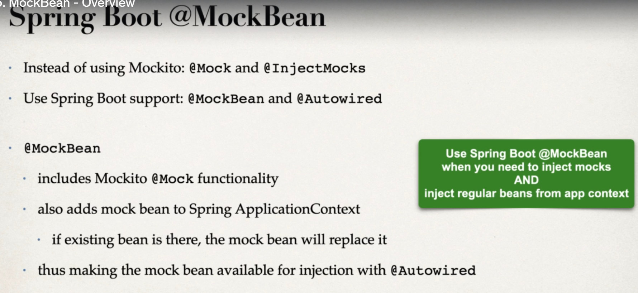

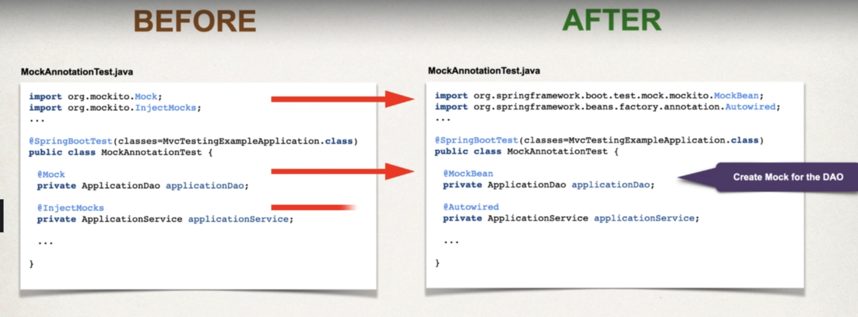

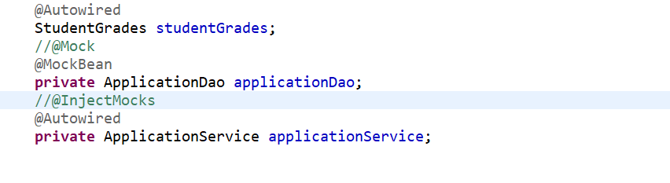

**THROWING EXCEPTIONS**

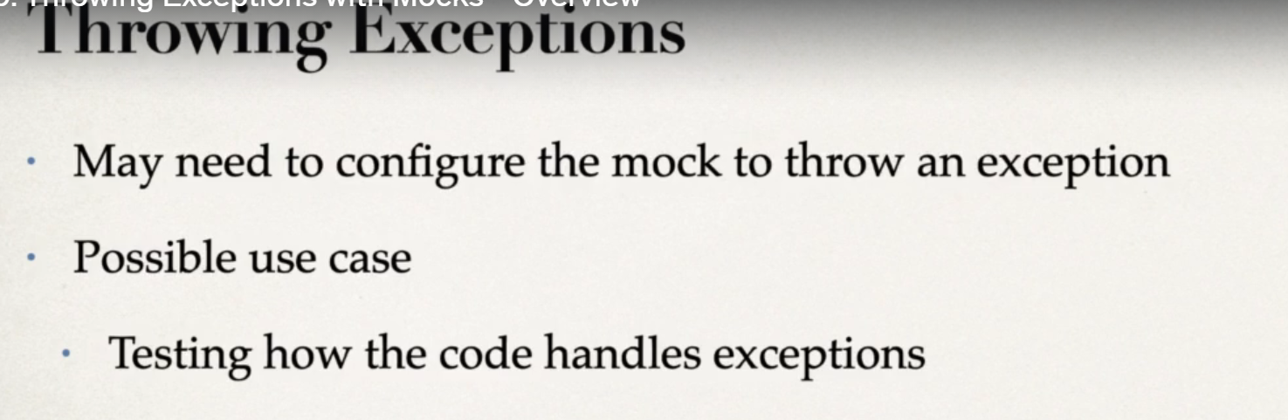

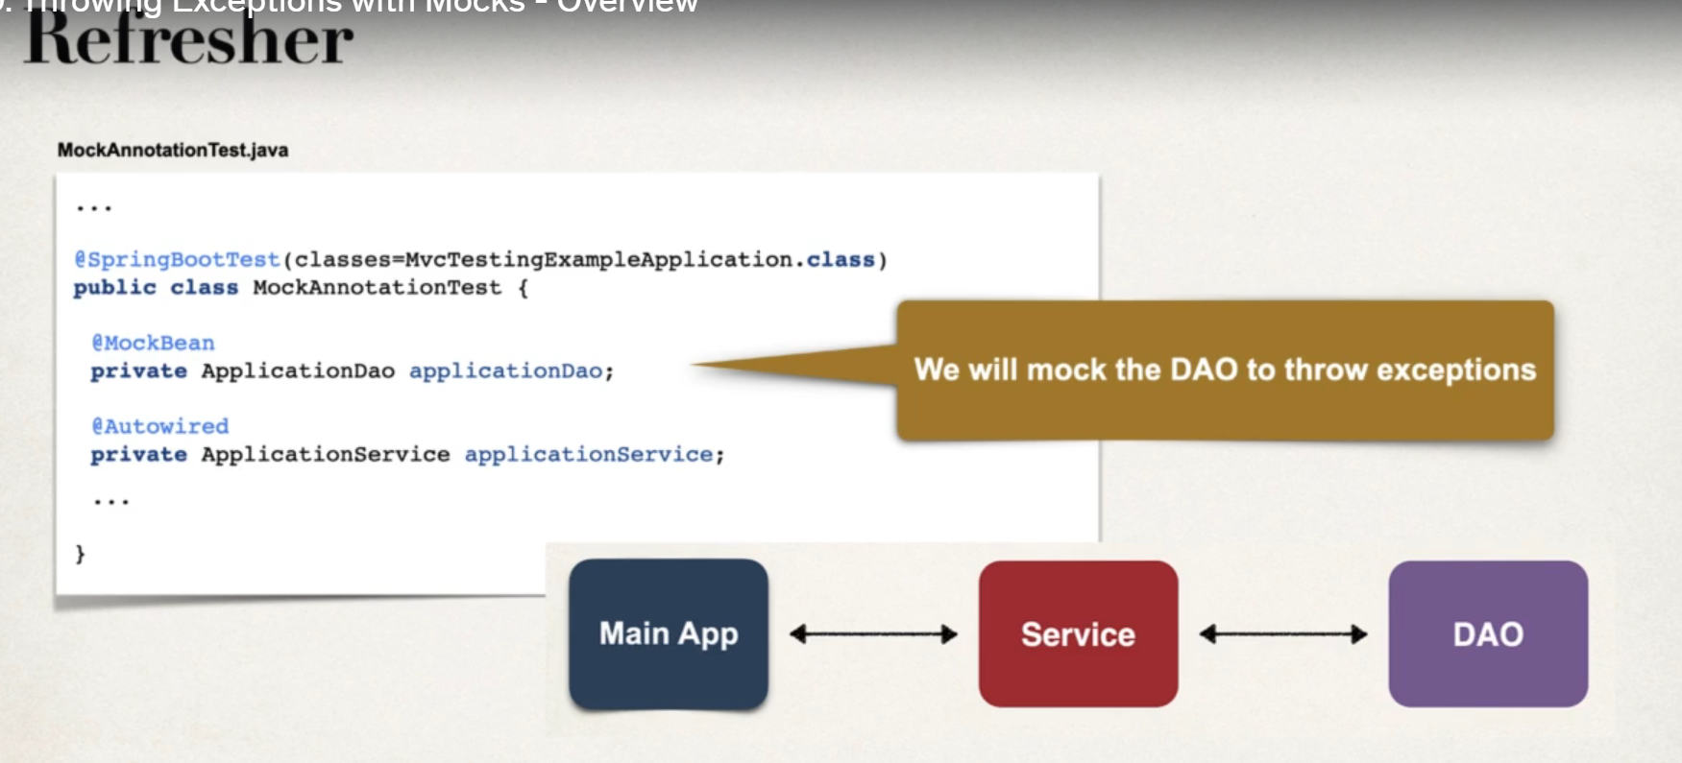

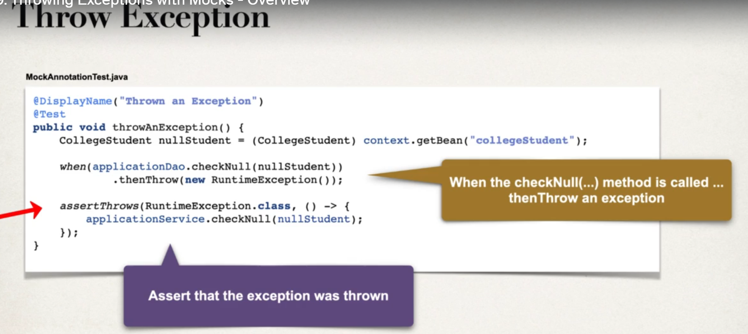

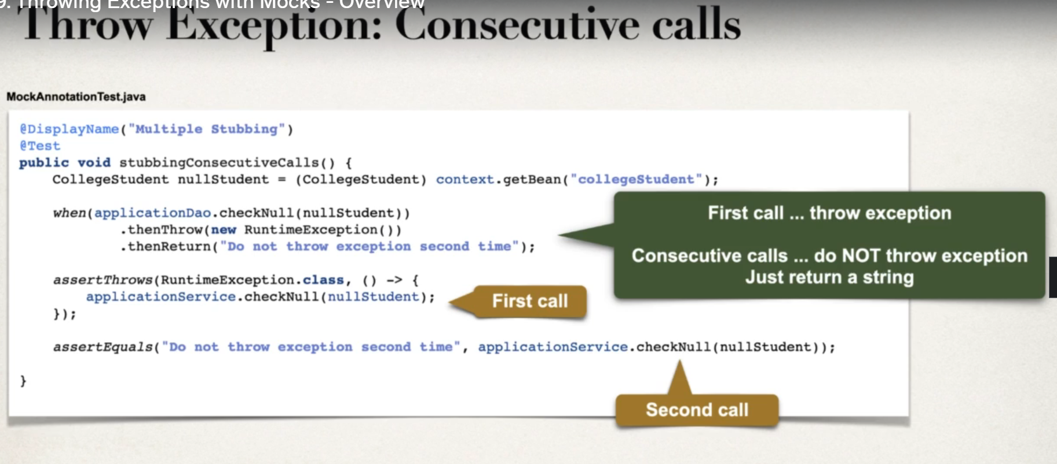

REFLECTION API

